LAB ACTION PLAN FOR WEEK 10
Minikube Automation Steps
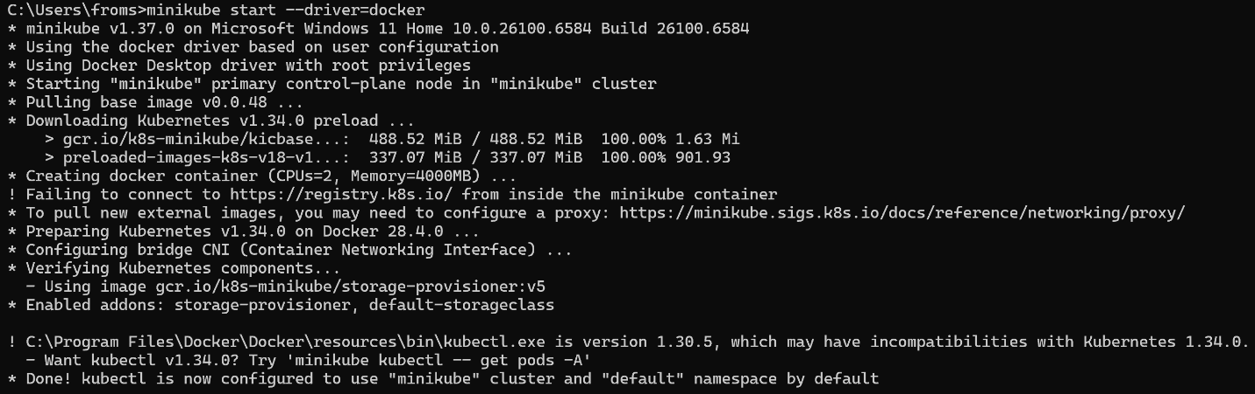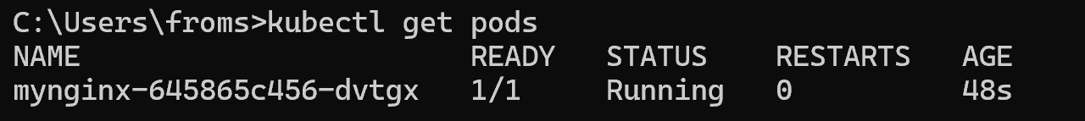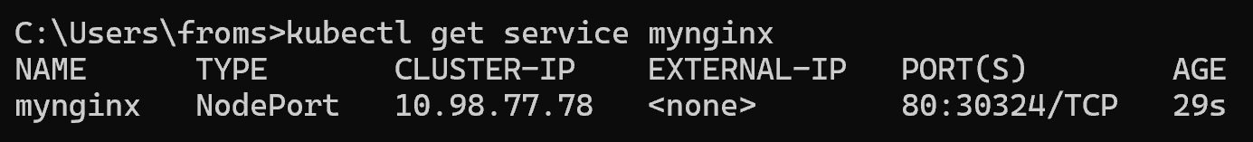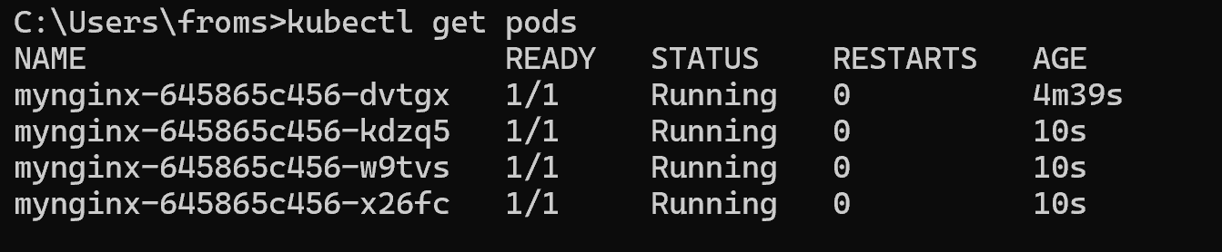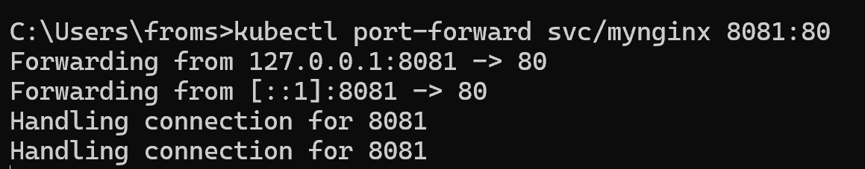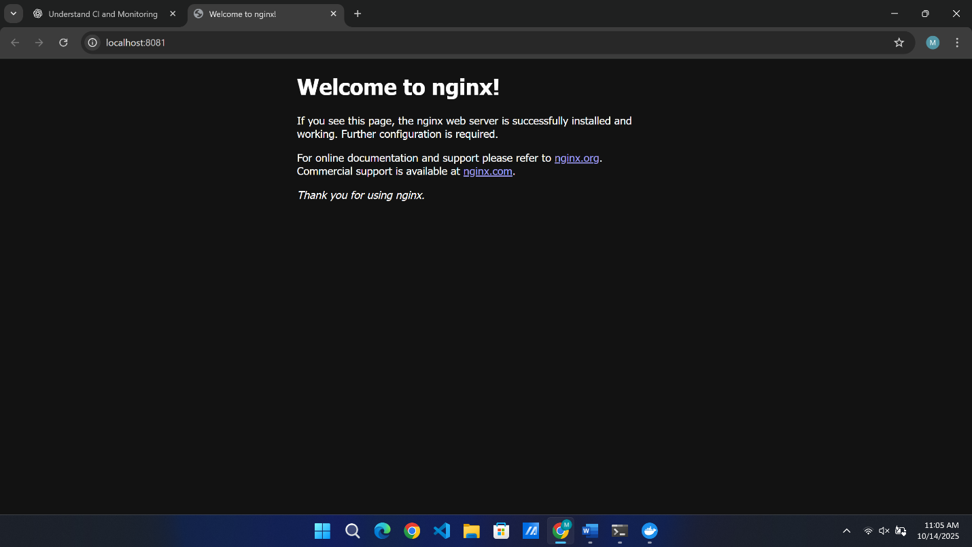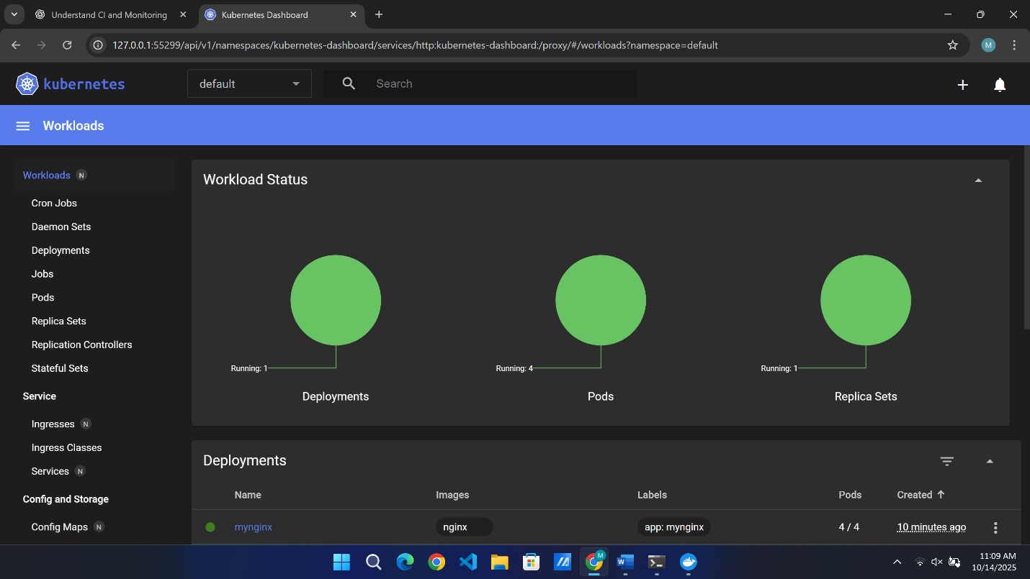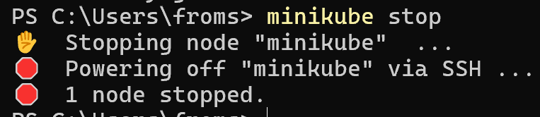

Nagios Automation Steps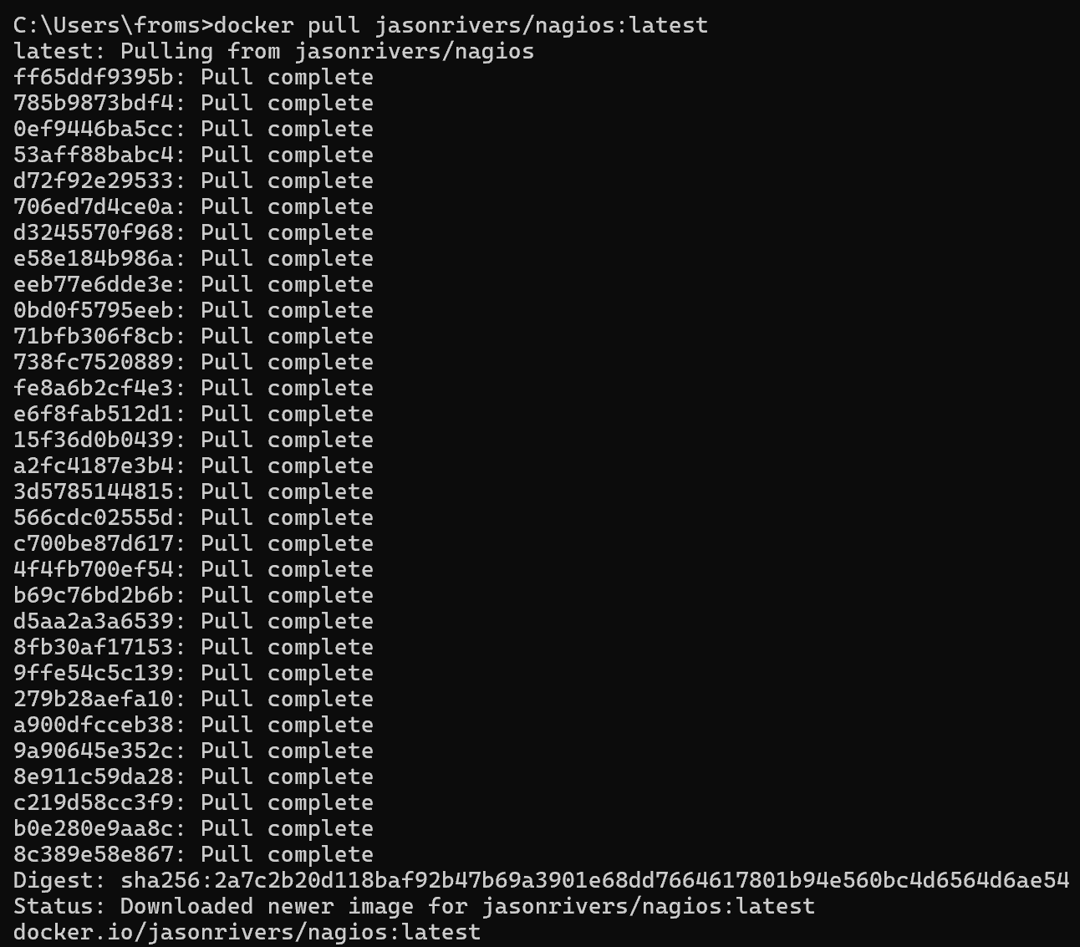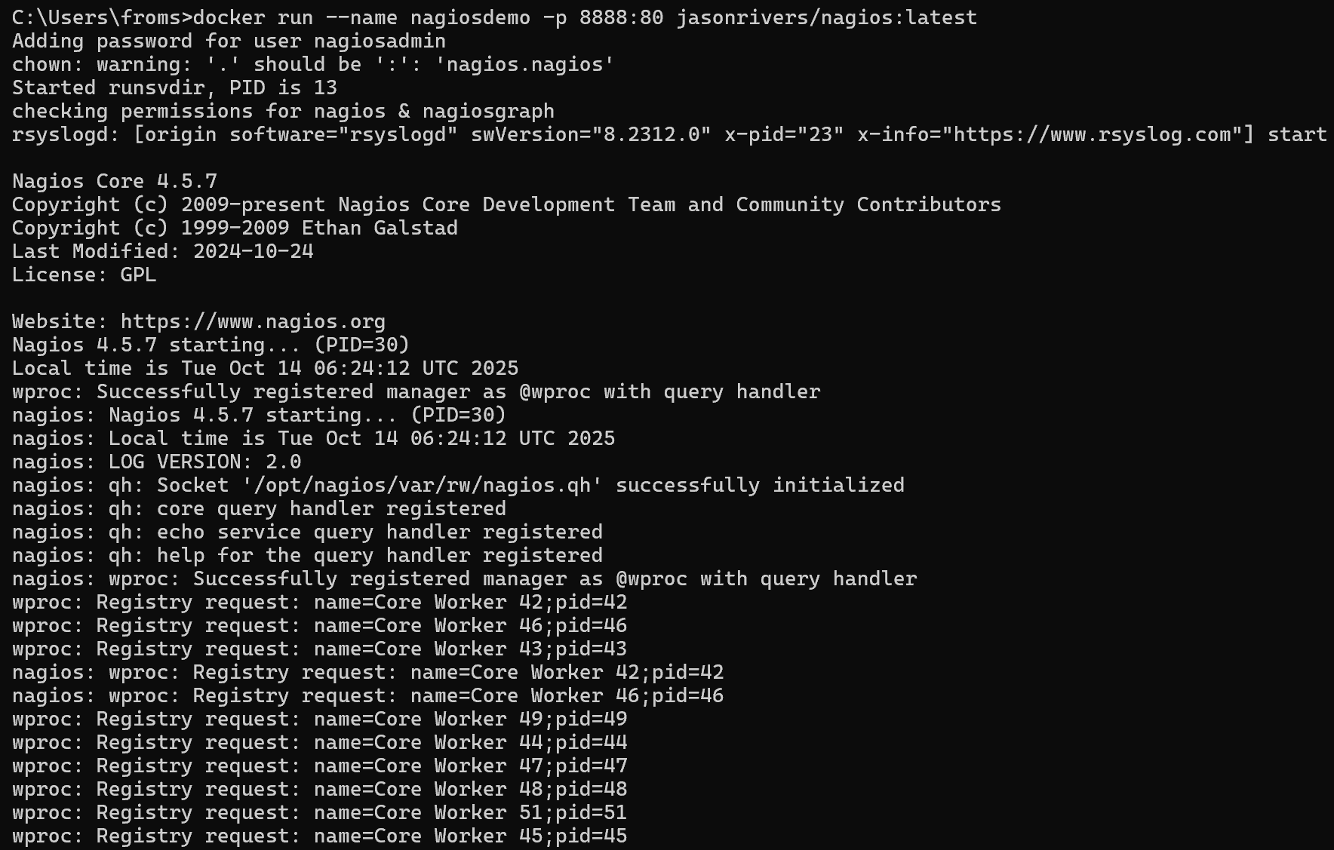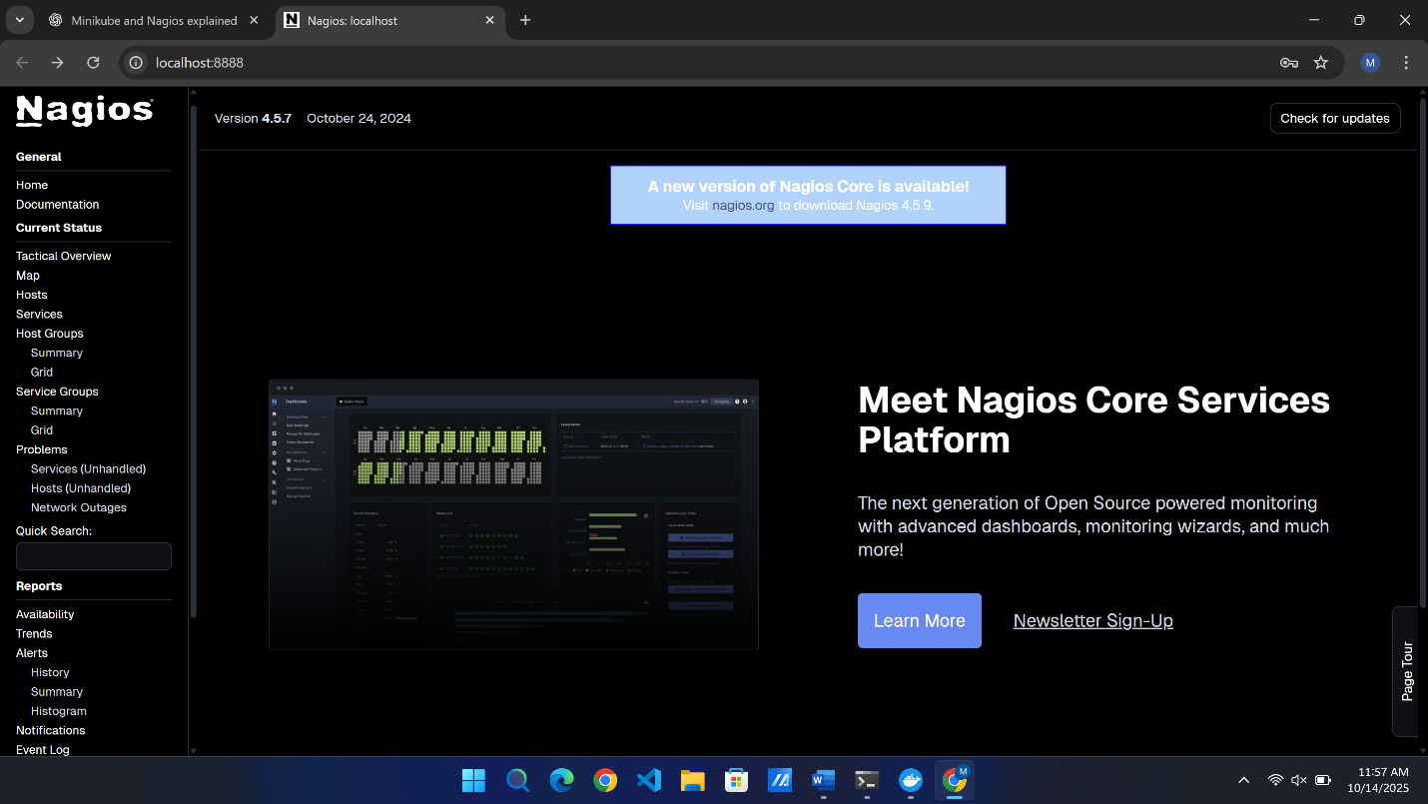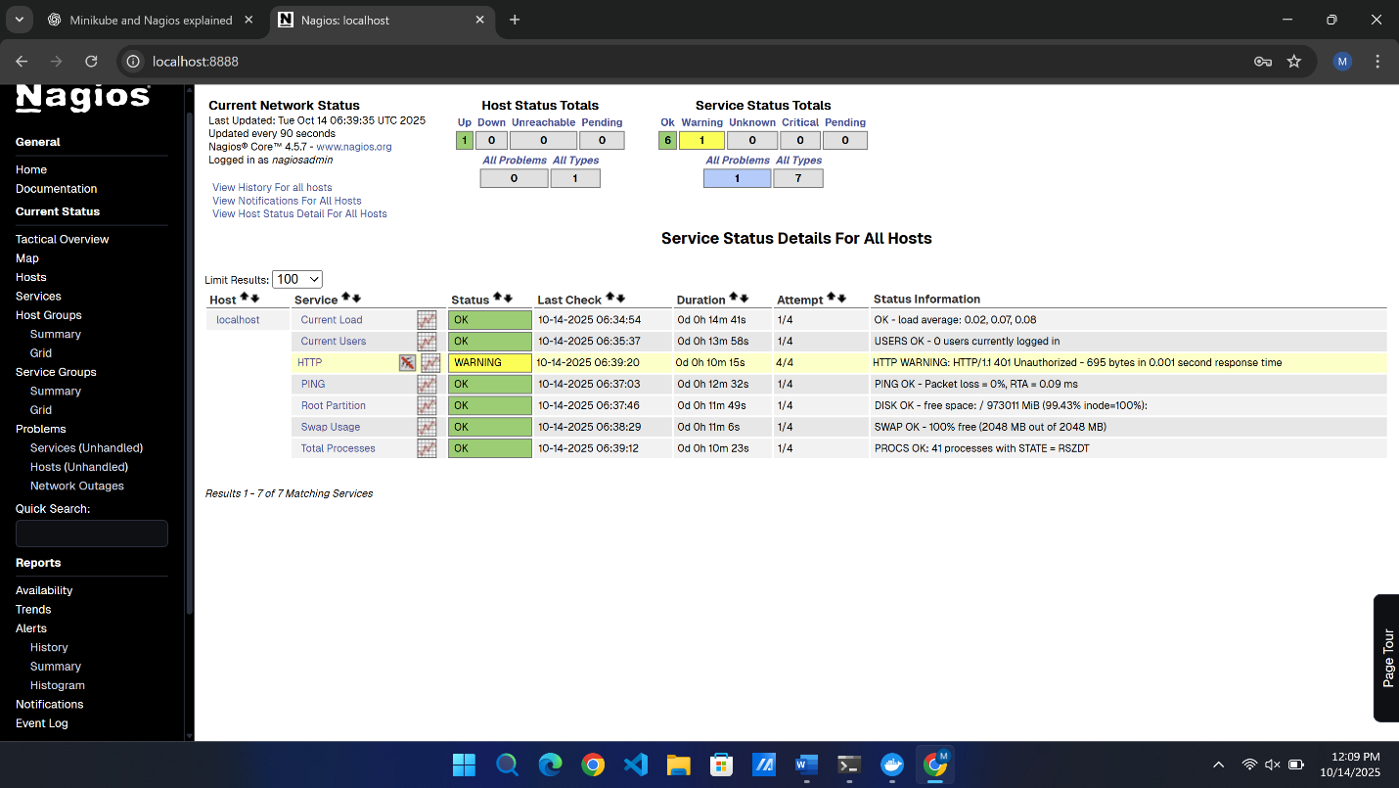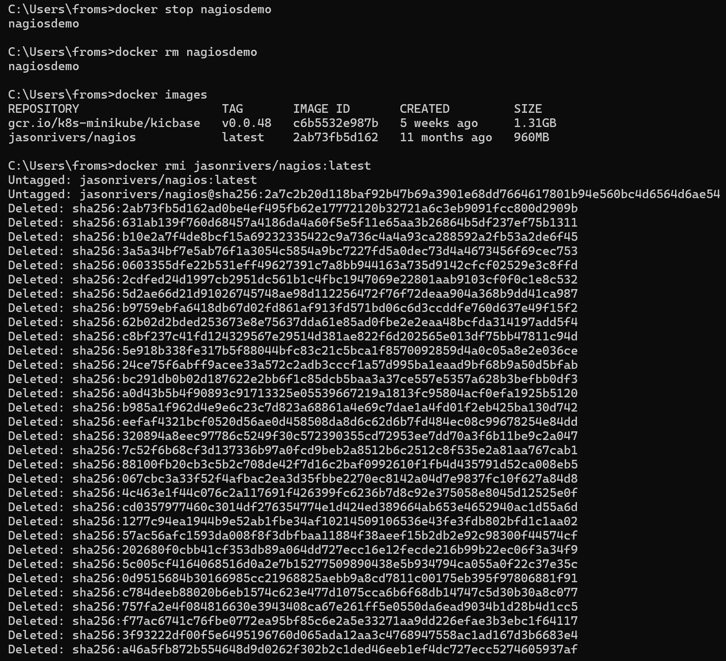

Kubernetes and Nagios SBQs

1. Your Pod keeps restarting repeatedly. What will you do?
If a pod keeps restarting, it usually means the application inside it is crashing.
To check the reason, run kubectl describe pod podname and kubectl logs podname --previous.
Common causes include wrong image, code errors, or failed health checks.
Fix the issue and redeploy.

2. A Kubernetes pod is stuck in a "Pending" state. What could be the possible reasons, and how would you troubleshoot it?
A pod stays pending when Kubernetes cannot schedule it on any node.
Reasons may include lack of resources, node not ready, or missing storage.
Use kubectl describe pod podname to find the reason and fix it, such as freeing memory or adjusting limits.

3. How would you debug a failed deployment in Kubernetes?
First, check if pods are created using kubectl get pods.
If not, run kubectl describe deployment name to see the problem.
View logs with kubectl logs podname.
Usually, it happens due to a wrong image name or incorrect configuration.

4. You have a Kubernetes Deployment with multiple replicas, and some pods are failing health checks. How would you identify the root cause and fix it?
Check the probe details using kubectl describe pod podname and logs using kubectl logs podname.
Common causes are wrong port, path, or app not ready in time.
Fix the probe settings or ensure the app starts properly.

5. How do you roll back a faulty deployment?
Use the command kubectl rollout undo deployment/deploymentname to return to the last working version.

6. How do you debug a running Pod?
You can open the pod’s shell using kubectl exec -it podname -- cmd to check files and logs.
You can also view detailed info with kubectl describe pod podname.

7. You need to expose a local service externally. How to do?
To make a service accessible outside, use kubectl expose deployment appname --type=LoadBalancer --port=80.
If using Minikube, run minikube service servicename to open it in the browser.

8. How to Start and stop Nagios
If using Docker, start with docker start nagiosdemo and stop with docker stop nagiosdemo.
If installed directly, open Windows Services, find Nagios, and click Start or Stop.

9. You installed Nagios but the web interface shows “Unable to connect to Nagios process”. How to resolve this?
It means the Nagios service is not running.
Start it again with docker start nagiosdemo or restart it from Windows Services.
Then refresh the browser.

10. You added a new host in Nagios, but it’s not appearing on the web interface. How to check?
The configuration may not have been applied.
Restart the container using docker restart nagiosdemo and check again in the dashboard.

11. How can you check whether Nagios is running properly?
In Docker, run docker ps to see if Nagios is active.
If it appears with port 8888, it’s running.
You can also open http://localhost:8888 to confirm the dashboard is accessible.

12. How do you view Nagios logs in real-time?
Run docker logs -f nagiosdemo to see live Nagios activity and alerts.

13. What are the advantages of using Nagios?
Nagios continuously monitors systems and alerts for any issues.
It tracks CPU, memory, and network, helping find problems early.
It keeps servers running smoothly and provides detailed reports.

